Software Requirements Specification
for
World Wide Banking
Version <1.5>

Prepared by

Neghea Serban Elyan | Student
Perisoara Mihai Cezar | Student
Popa Mihai Alexandru | Student

Instructor: | Cosmin Stoica Spahiu
Course: | Project II – Use Of Databases
Date: | 13.03.2020
Table of Contents
Table of Contents ii
1 Introduction 1
1.1 Document Purpose 1
1.2 Product Scope 1
1.3 Definitions, Acronyms and Abbreviations 1
1.4 References and Acknowledgments 1
2 Overall Description 2
2.1 Product Functionality 2
2.2 End Users and Characteristics 2
2.3 System Stakeholders 2
2.4 Operating Environment 3
3 Specific Requirements 5
3.1 User Interface 5
3.2 Functional Requirements 5
3.3 Use Case Diagram 13
4 Non-functional Requirements 16
4.1 Software Quality Attributes 16
5 Other Requirements 17
Appendix A - Group Log 17

Introduction

Document Purpose
The purpose of this document is to build an online banking system, so a customer could manage with ease its own bank account.

Product Scope
Our product, entitled “World Wide Banking”, is an online payment system that allows our customers to conduct financial transactions. The customers can check at any time their account balances and view data about their account, can check their last transactions, can transfer money at any time from one account to another and they are also able to make payments to various services (electricity, telephone, internet and so on).
All of the information from above is stored in a database, all of the customers’ data about their accounts plus other data that is not available to a customer, like last successful login and the date when they activated their online banking service.

Definitions, Acronyms and Abbreviations
FAQ – Frequently Asked Questions
SRS – Software Requirements Specification

References and Acknowledgments
Wiki Online Banking
About GitHub
About ASP.NET
About HTML
About CSS

Overall Description

Product Functionality
The product’s main functionality is the administration of a bank account. The first required step in doing like so is successfully logging into the account which can be a client account or an admin (/employee) account (discussed in the next part).
If the user is not registered, there’s a register form to complete. There is also a “Contact Us” button for the case in which the user encounters any difficulties while logging in or registering on the platform.
The login page is as straightforward as it seems, requiring the user to fill the form with the user and password. After logging in, the user is able create a new bank account, manage an existing account or delete it.
Both creating and deleting an account will require the end-user to enter the pin in order to set up the new account, respectively to confirm the removal of the account. In the main page, the user will be able to monitor how much money was spent, where it was spend and how much is left in the account. Also, he will be able to change the pin, send and receive money.

End Users and Characteristics
As stated before, there are 2 types of end-users. The first one is the client, which, once logged in, can create a bank account, delete it or change it’s PIN. He can also send money and receive money (the user is notified upon receiving money).

The other type of user is the admin which is a bank employee. He is able to modify the name, address, postal code, city, district, country, email and phone number upon request if the change is proven to be correct. He is able to see the username but not the password, both being unmodifiable, he can only delete the account if it’s requested. The admin is also able to see the the activity of a certain account, including last time online, active balance and transaction history.

System Stakeholders
A system stakeholder is an individual, team, organization, or classed thereof, having an interest in realization of a system. Therefore the stakeholders for this project can be classified according to their roles and concerns as following:
  - The end-users, in the largest number, define the system’s functionality and ultimately make use of it.
  - The testers are responsible for the end user’s experience using the application, ensuring that it’s suitable for a public release.
  - The admins are the ones who run the system once it has been deployed. Their purpose is to mentain the system operational and manage it’s potential evolution.
  - The support team also has a crucial role in the experience of using an application, being able to help the end-users with any difficulties that might appear.
  - The production engineers are responsible for designing and managing the hardware and software environments in which the system will be built, tested and run.
  - The developers are little delicate machines, powered by coffee, which are responsible for the construction and deployment of the system.

Operating Environment
An operating environment (/integrated applications environment) is the environment in which the end-users run the application software consisting in a server-sided part, accessible only by the admins, and a public client, run by the average user.
The minimum server-sided system requirements
  - Intel Xeon
  - 512MB (for the system) + 512GB (for each 10 concurrent users)
  - Windows Server 2008 (build 6001)
Recommended server-sided system requirements
  - Intel Xeon
  - 1GB (for the system) + 1GB (for each 10 concurrent users)
  - Windows Server 2019 v1809 (build17763)

The minimum client system requirements
  - Athlon/Opteron AMD64 /Intel Pentium 4
  - 1GB RAM
  - Windows 7 SP1 (build 7601) 64bit
Recommended client system requirements
  - Bulldozer FX-4100 /Skylake Intel i36098P
  - 3GB RAM
  - Windows 10 v1909 (build 183630) 64bit

Specific Requirements

User Interface
Added in a separate document

Functional Requirements

User login
ID: A0
Title: The user login page
Description: A page where the user will be able to log in to access his banking account information and will be able to do all kinds of operations to it. The admin can also log in to access all the information regarding the users that have an account in his system.
Why we need it: A banking application needs a page where the users can log in into their account so they can use various operations.
Dependency: None

Username field

ID: A1
Title: The user identification field
Description: This field contains the identification name of the user.
Why we need it: The user needs an identification name so he can be differentiated from the other users.
Dependency: A0

Password field

ID: A2
Title: The user password field
Description: This field contains the password of the user.
Why we need it: The user needs a password so he can log into the account and have a security assured to it.
Dependency: A0

Remember me box

ID: A3
Title: A button which has “Remember me” text next to it.
Description: The user isn’t required to input the username next time he logins if the box is checked, only needing to input the password.
Why we need it: This box is used for easy access.
Dependency: A0

Login button

ID: A4
Title: The login button
Description: Pressing this button will login the user into the system.
Why we need it: Without this button, the user cannot login.
Dependency: A0

User log out
ID: B0
Title: The user log out button
Description: This button allows the user to disconnect from his account and to return to the main page.
Why we need it: Without this button, the user cannot disconnect from his account, endangering his account’s security and also being locked in.
Dependency: None

Log out confirmation message

ID: B1
Title: The log out confirmation message
Description: This message prompts a question to the user asking whether he wants to log out of his account or not.
Why we need it: This confirmation message is needed for security and also in case of miss-clicks.
Dependency: B0

Register
ID: C0
Title: The register page
Description: This page allows the user to register his information to create an account for the banking website.
Why we need it: We need this page so the bank will be able to run, if there’s no users, there’s no clients for the bank.
Dependency: None

Name field

ID: C1
Title: The first name field
Description: This is the field where the user’s first name will be input.
Why we need it: The first name is needed to identify the owner of the account.
Dependency: C0

Surname field

ID: C2
Title: The second name field
Description: This is the field where the user’s second name will be input.
Why we need it: The second name is needed to identify the owner of the account along with the first name.
Dependency: C0

Phone number field

ID: C3
Title: The phone number field
Description: This is the field where the user’s phone number will be input.
Why we need it: The phone number is needed for contacting the user whether some issues arise regarding his bank account and his email isn’t reachable.
Dependency: C0

Password field

ID: C4
Title: The user password field
Description: This field contains the password of the user.
Why we need it: The user needs a password so he can log into the account and have a security assured to it.
Dependency: C0

Confirm password field

ID: C5
Title: The user password confirmation field
Description: This field contains once again the password of the user.
Why we need it: The user needs to input the password once again in the text boss, so it is assured he remembers the password.
Dependency: C0

Address field

ID: C6
Title: The address field
Description: This field contains the address of the user.
Why we need it: The address is needed as a additional proof from the client, requested by the bank.
Dependency: C0

Postal code field

ID: C7
Title: The postal code field
Description: This field contains the postal code of the user.
Why we need it: The postal code is part of the address which is needed as a additional proof from the client, requested by the bank.
Dependency: C0

City field

ID: C8
Title: The city field
Description: This field contains the city of the user.
Why we need it: The city is part of the address which is needed as a additional proof from the client, requested by the bank.
Dependency: C0

County field

ID: C9
Title: The county field
Description: This field contains the county of the user.
Why we need it: The county is part of the address which is needed as a additional proof from the client, requested by the bank.

Dependency: C0

Country field

ID: C10
Title: The country field
Description: This field contains the country of the user.
Why we need it: The country is part of the address which is needed as a additional proof from the client, requested by the bank.

Dependency: C0

Email field

ID: C11
Title: The email field
Description: This is the field where the user’s email address will be input.
Why we need it: The email is needed for contacting the user whether some issues arise regarding his bank account.
Dependency: C0

CNP

ID: C12
Title: The CNP field
Description: This is the field where the user’s personal numeric code will be input.
Why we need it: The CNP is needed to identify is the person is the real owner, for security measures.
Dependency: C0

Register button

ID: C13
Title: The register button
Description: Pressing this button will register the user into the system with the info typed into the fields above it.
Why we need it: Without the button, the user isn’t able to finalise his registration and thus, isn’t able to create an account.
Dependency: C0

Create banking account
ID: D0
Title: The page where a banking account is created
Description: This page allows the user to create a banking account.
Why we need it: A user is a client which in order to use the banking facilities needs to create a banking account
Dependency: None

Type of account (EUR, RON, USD)

ID: D1
Title: The field where the type of account is chosen
Description: This field allows the user to choose one of the 3 types of accounts, EUR, RON or USD.
Why we need it: One of the options is mandatory so a currency is chosen for the bank account.
Dependency: D0

Create the banking account button

ID: D2
Title: The button which creates a banking account.
Description: Pressing the button created the new banking account with the chosen type and PIN from before.
Why we need it: We need this button in order to create the account.
Dependency: D0

Showing the data of the card after creation

ID: D3
Title: The data of the card will be shown after creation
Description: After the banking account will be created, all the info regarding it will be shown to the user.
Why we need it: It’s necessary because the user needs to know all the info about the account.
Dependency: D0

Delete banking account
ID: E0
Title: The page where a banking account is deleted
Description: This page allows the user to delete a banking account.
Why we need it: A user is a client which if he decides to close the account, the bank must comply according to his wish.
Dependency: None

Confirmation button

ID: E1
Title: The confirmation button
Description: This button is the last step in order to confirm the decision of the user.
Why we need it: The confirmation button is needed in case of security issues.
Dependency: E0

Delete banking account button

ID: E2
Title: The button which deletes the banking account
Description: Pressing this button finalises the deletion of the banking account, and it’s the final step in doing so.
Why we need it: Without it, we aren’t able to delete the banking account.
Dependency: E0

Exchange rates
ID: F0
Title: The place where the exchange rates for different currencies are shown
Description: This place shows the exchange rates for different currencies, like RON, USD and EUR.
Why we need it: The user needs to know how currencies convert from one to another.
Dependency: None

Transfer money
ID: G0
Title: The transfer money page
Description: This is where the user can transfer money from his own bank account to another bank account by inputting the IBAN of it and the sum.
Why we need it: This is a basic feature that is needed in any bank.
Dependency: None

Input IBAN

ID: G1
Title: The field where the IBAN is input
Description: This is where the user inputs the IBAN of the banking account to be the recipient of the sum of money.
Why we need it: This is needed to know where to transfer the money.
Dependency: G0

Input sum

ID: G2
Title: The field where the sum is input
Description: This is where the user chooses how much money is transferred from his own bank account.
Why we need it: This is needed to know how much money needs to be transferred.
Dependency: G0

Transfer money button

ID: G3
Title: The transfer money button
Description: This button transfers the sum of money to the chosen IBAN.
Why we need it: Without the button, the user wouldn’t be able to transfer the money.
Dependency: G0

Receive money
ID: H0
Title: The money received page
Description: This is where the money is received from another bank account.
Why we need it: This is a basic feature that is needed in any bank.
Dependency: None

Notification of the amount and source

ID: H1
Title: The notification of the money received
Description: This is a notification which shows to the user how much money he received and from where.
Why we need it: Without this notification, the user wouldn’t know why money is showing up in his account.
Dependency: H0

Help page
ID: I0
Title: The help page of the bank website
Description: This is where the user can go if he has any issues regarding the banking account or the account in general.
Why we need it: Without this page, the user may have issues and he won’t be able to solve them.
Dependency: None

FAQ

ID: I1
Title: The page where the FAQ is
Description: This is where the user can read the frequently asked questions by other users which may coincide with his.
Why we need it: Those questions were chosen from the questions of other users which always coincided.
Dependency: I0

Additional contact us button

ID: I2
Title: The contact us button
Description: This is where the user can contact the administrator in case his question isn’t one of those frequently asked.
Why we need it: This is needed because the user may have issues which can’t be solved by the FAQ.
Dependency: I0

Use Case Diagram
Activities Diagram

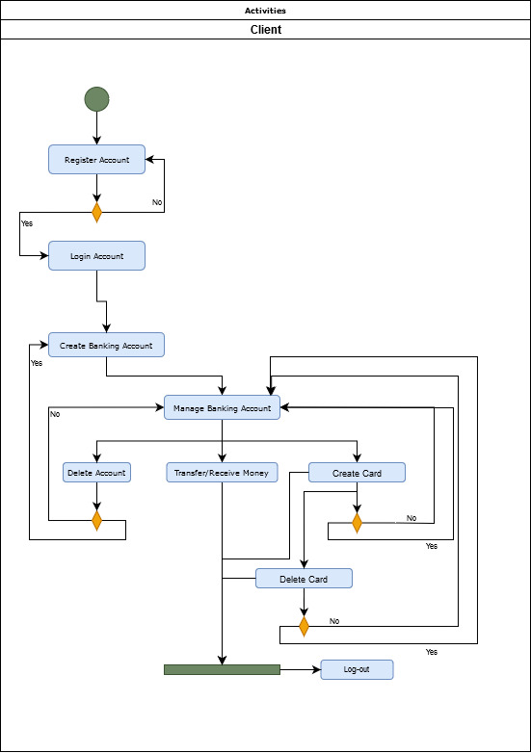
Class Diagram

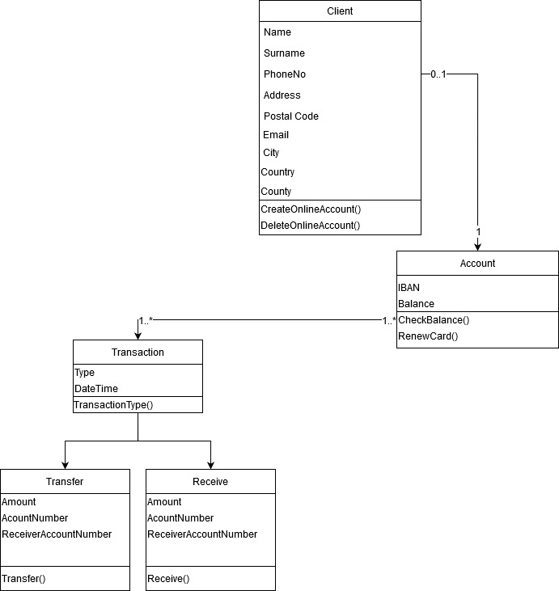
Relational Model
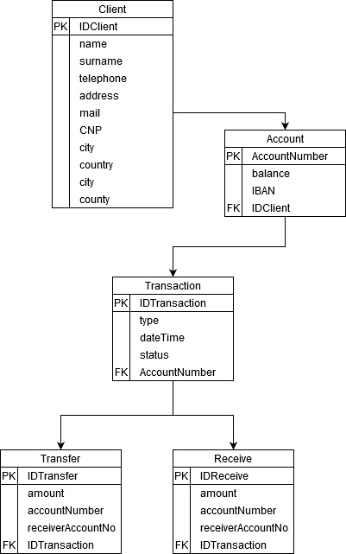

Use-Case Diagram
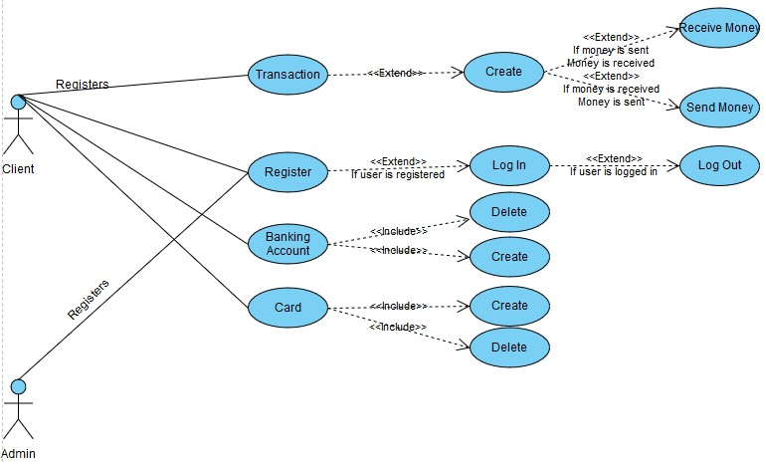

Non-functional Requirements

Software Quality Attributes

Any user can access the system using even a low performance PC, stated at the end of the 2nd chapter.
Rule 1(required) Source code should have comments.
Rule 2(advisory) No identifier name should be reused.
Availability: the system is available 24 hours a day.
Portability: a user can log in to the system at any time.
Reliability: the system can be used by multiple users concurrently. Any user can access the system using even a low performance PC.
Rule 3(required) All automatic variables should have been assigned a value before being used.
Rule 4(advisory) The increment (++) and decrement (--) operators should not be mixed with other operators in an expression.
Rule 5(advisory) Write only one declaration per line.
Rule 6(advisory) Use meaningful names for variables.
Rule 7(required) All if … else if constructs shall be terminated with an else clause.
Rule 8(required) All constants must be declared with capital letters and underline between words.
Rule 9(required) The operands of a logical && or || shall be primary-expressions.
Rule 10(required) There shall be no unreachable code.

Other Requirements

Security
Access will be provided with a username and a password for the user. The username and password are case-sensitive.
The username and password are chosen at the register password where the user will create an account for personal use.
The banking account has a PIN protection, which means that it’s secured and only the client knows the PIN.

Safety
N/A

Appendix A - Group Log
<Please include here all the minutes from your group meetings, your group activities, and any other relevant information that will assist the instructor to determine the effort put forth to produce this document>

